**Fall 2019**

**CSE-5321-002 - Software Testing**

**Homework Assignment 5**

|  |  |
| --- | --- |
| **Name** | **UTA ID** |
| Goutami Padmanabhan | 1001669338 |

Please find the CSV files I used for testing (/CsvTestCaseTables) and Junit test files (/JUnitTestClassFiles), attached to the zip file I submitted. I have also attached the HTML files (/PIT html files) obtained from PIT Mutation test.

**Problem 1**

**1.Test Case Table:**

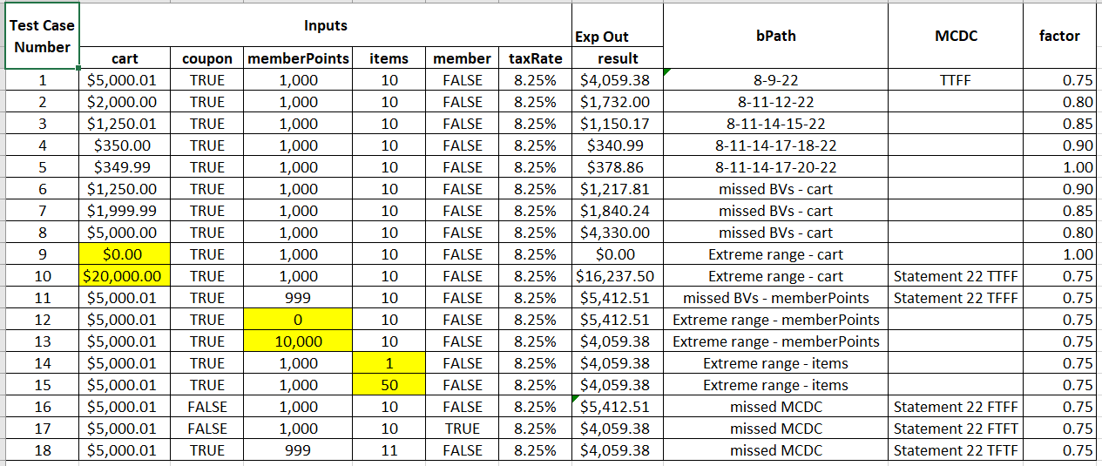

**2. JUnit Pass Indicator:**

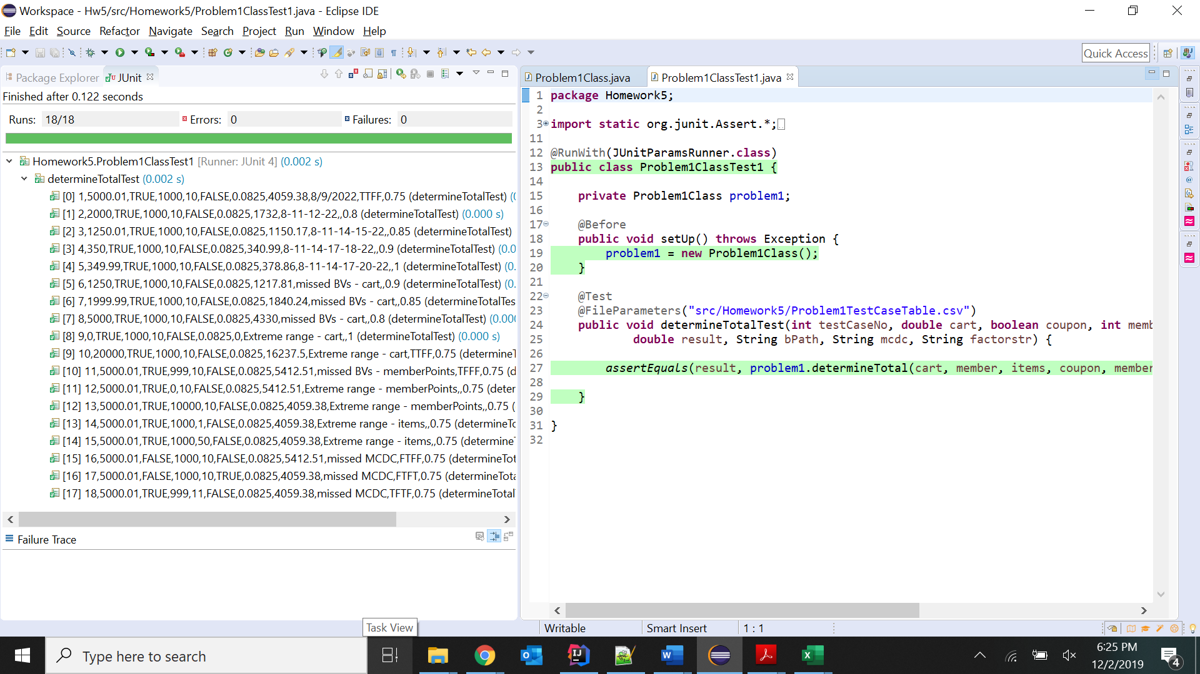

**3. JaCoCo Coverage:**

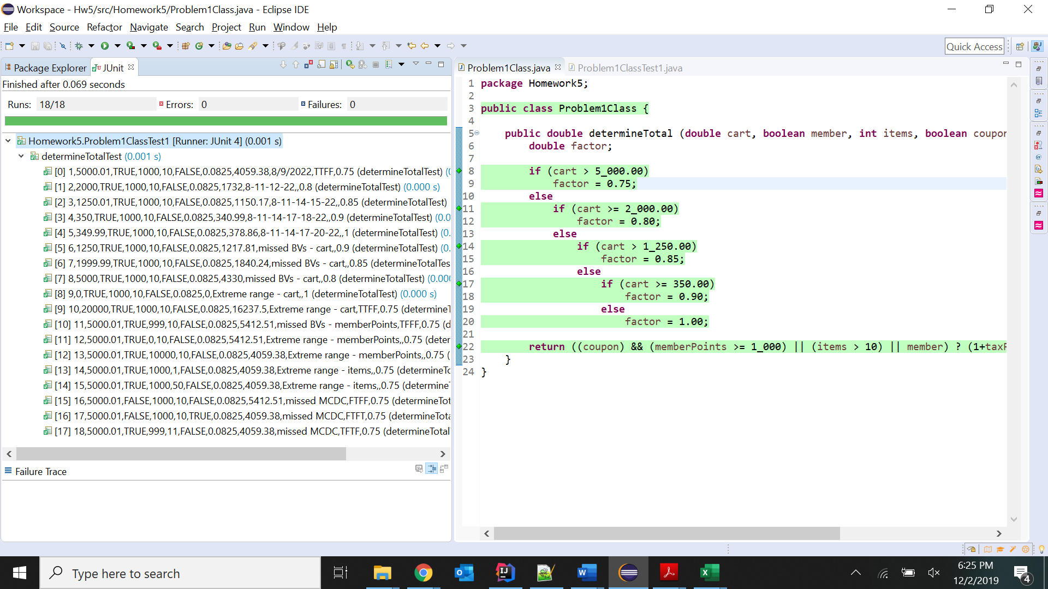

**Problem 2**

**1.Test Case Table:**

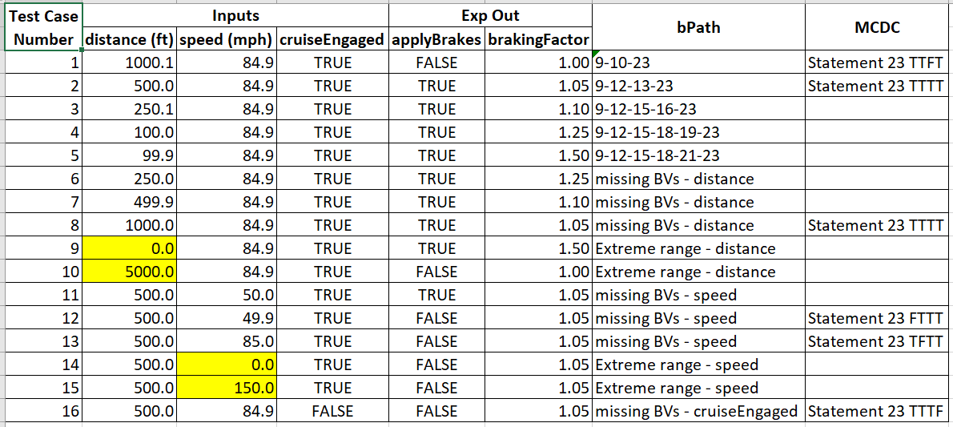

**2. JUnit Pass Indicator:**

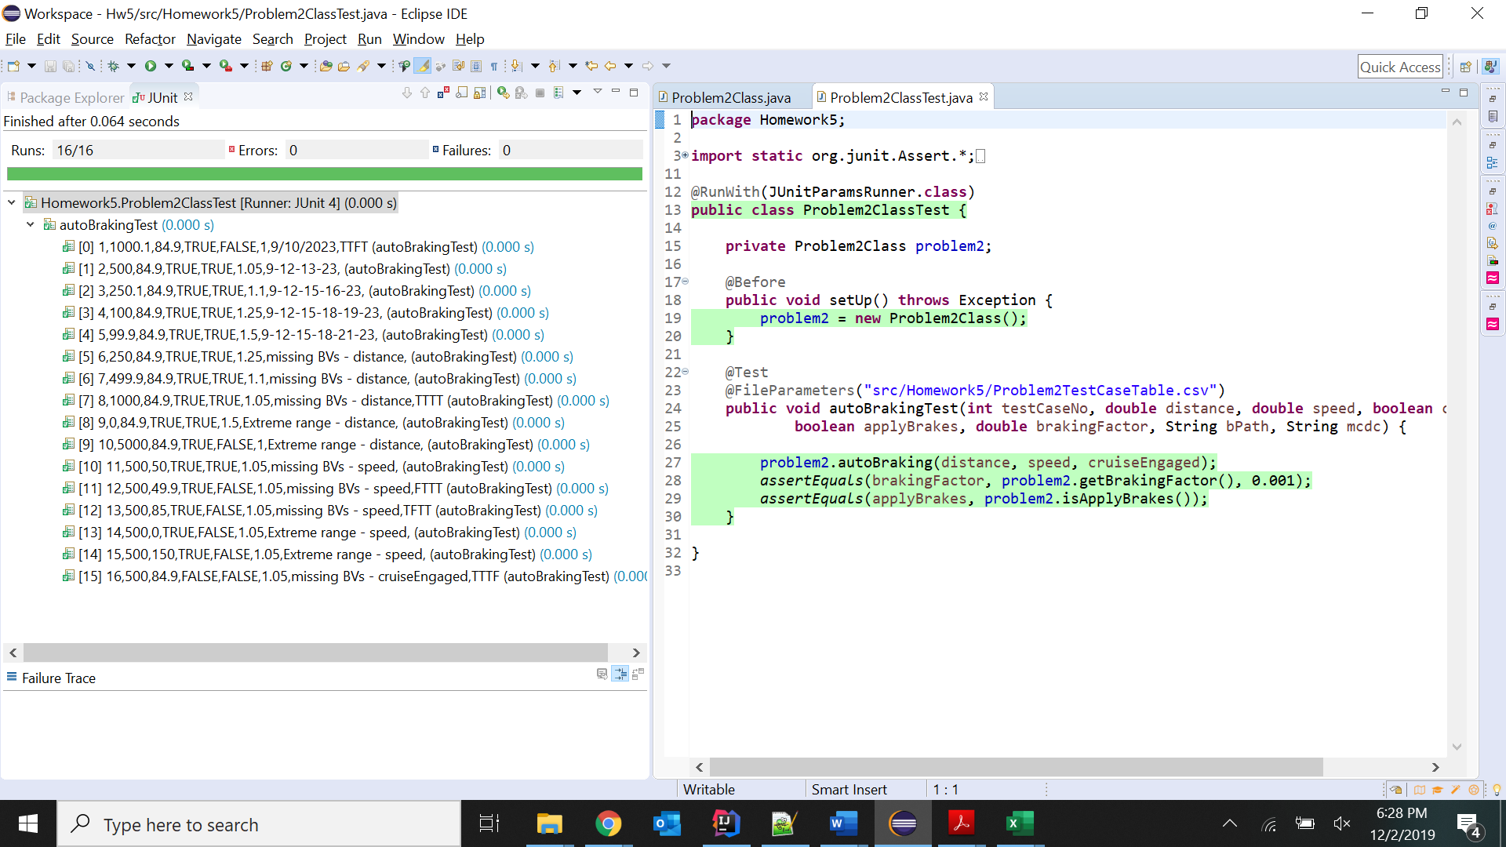

**3. JaCoCo Coverage:**

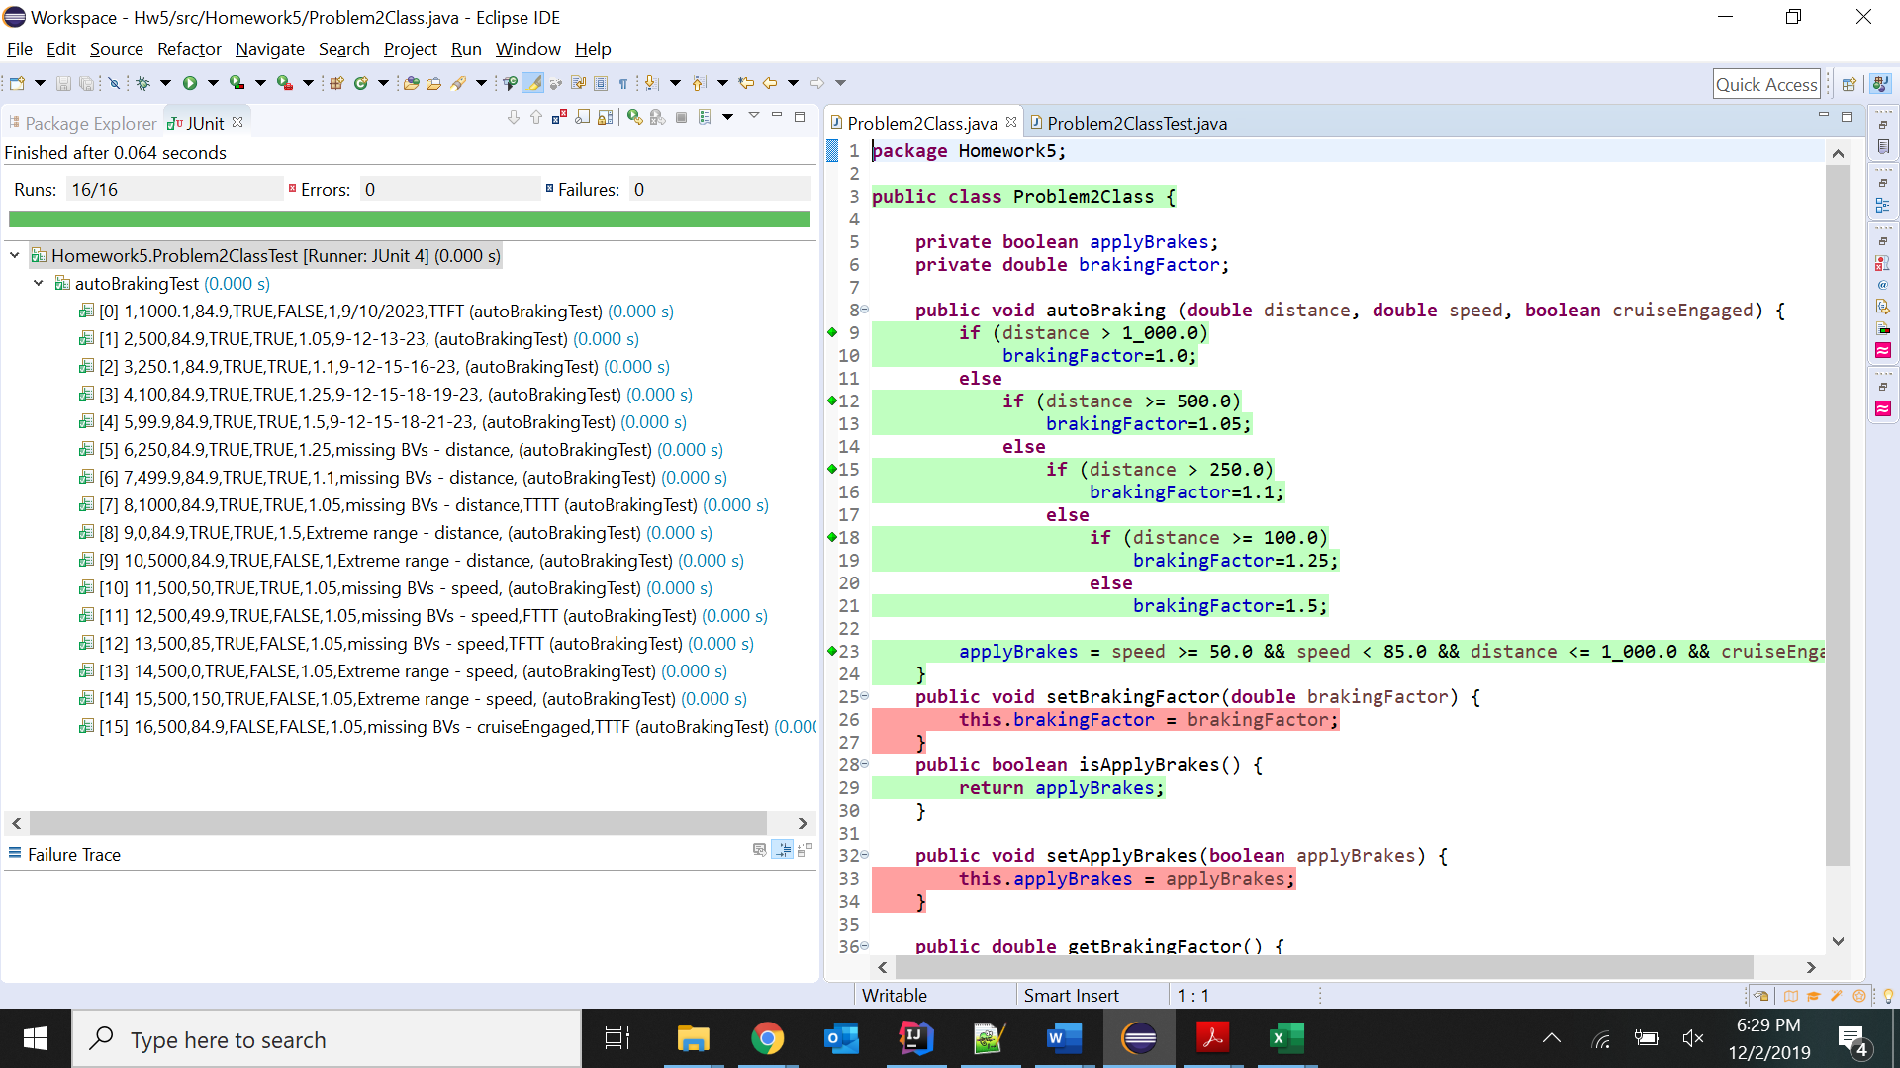

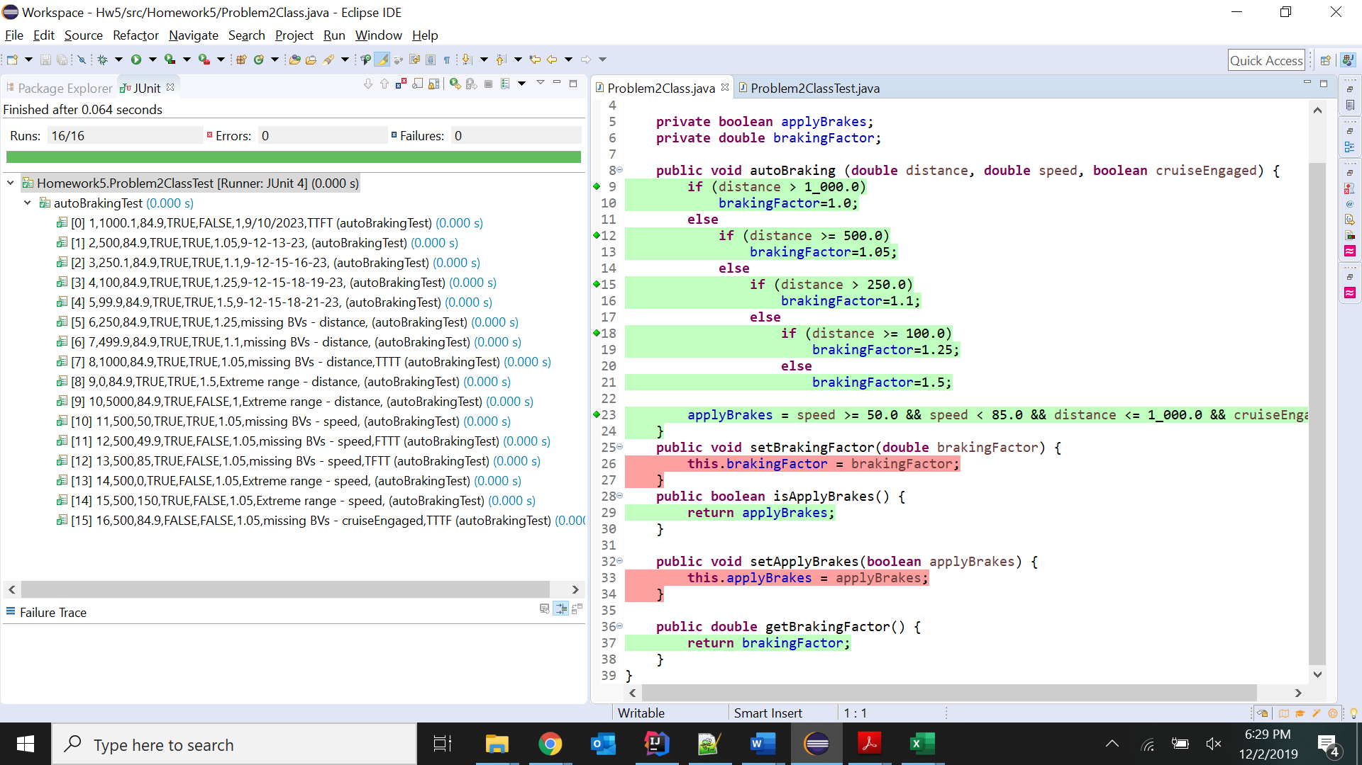

**Problem 3**

**1.Test Case Table:**

|  |  |  |  |  |  |
| --- | --- | --- | --- | --- | --- |
| **Test Case Number** | **Inputs** | | | **Exp Out** | **MCDC** |
| **month** | **day** | **year** | **result** |
| 1 | 1 | 1 | 2019 | 365 | Statement 8 TT and Statement 9 TFT |
| 2 | 1 | 2 | 2019 | 1 | Statement 8 TF |
| 3 | 2 | 1 | 2019 | 31 | Statement 8 FT and Statement 12 TFT |
| 4 | 1 | 1 | 2021 | 366 | Statement 9 FFT |
| 5 | 1 | 1 | 2101 | 365 | Statement 9 FTT |
| 6 | 1 | 1 | 2401 | 366 | Statement 9 FTF |
| 7 | 1 | 2 | 2020 | 1 | Statement 12 FFT |
| 8 | 1 | 2 | 2100 | 1 | Statement 12 FTT |
| 9 | 2 | 1 | 2400 | 31 | Statement 12 FTF |
| 10 | 1 | 2 | 2399 | 1 | Missing BVs for Statement 9 |
| 11 | 1 | 2 | 2099 | 1 | Missing BVs for Statement 9 |
| 12 | 1 | 1 | 2400 | 365 | Missing BVs for Statement 12 |
| 13 | 1 | 1 | 2100 | 365 | Missing BVs for Statement 12` |

**2. JUnit Pass Indicator:**

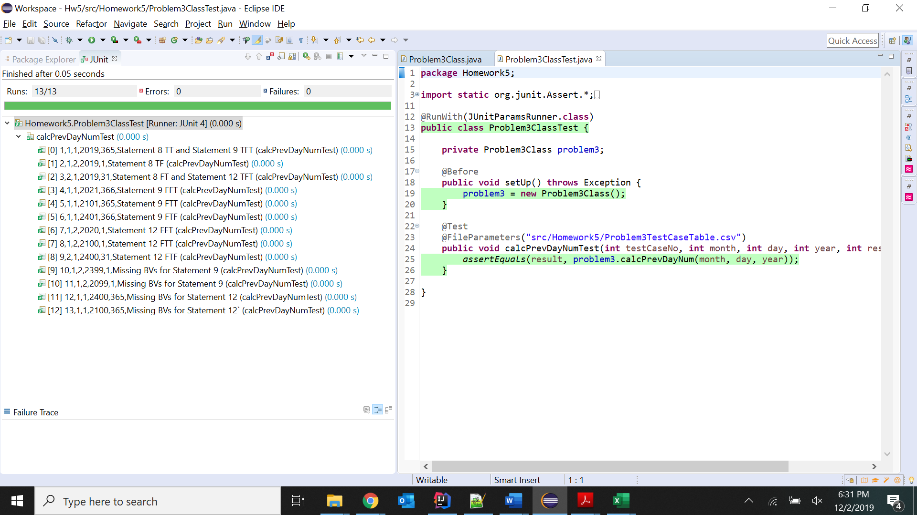

**3. JaCoCo Coverage:**

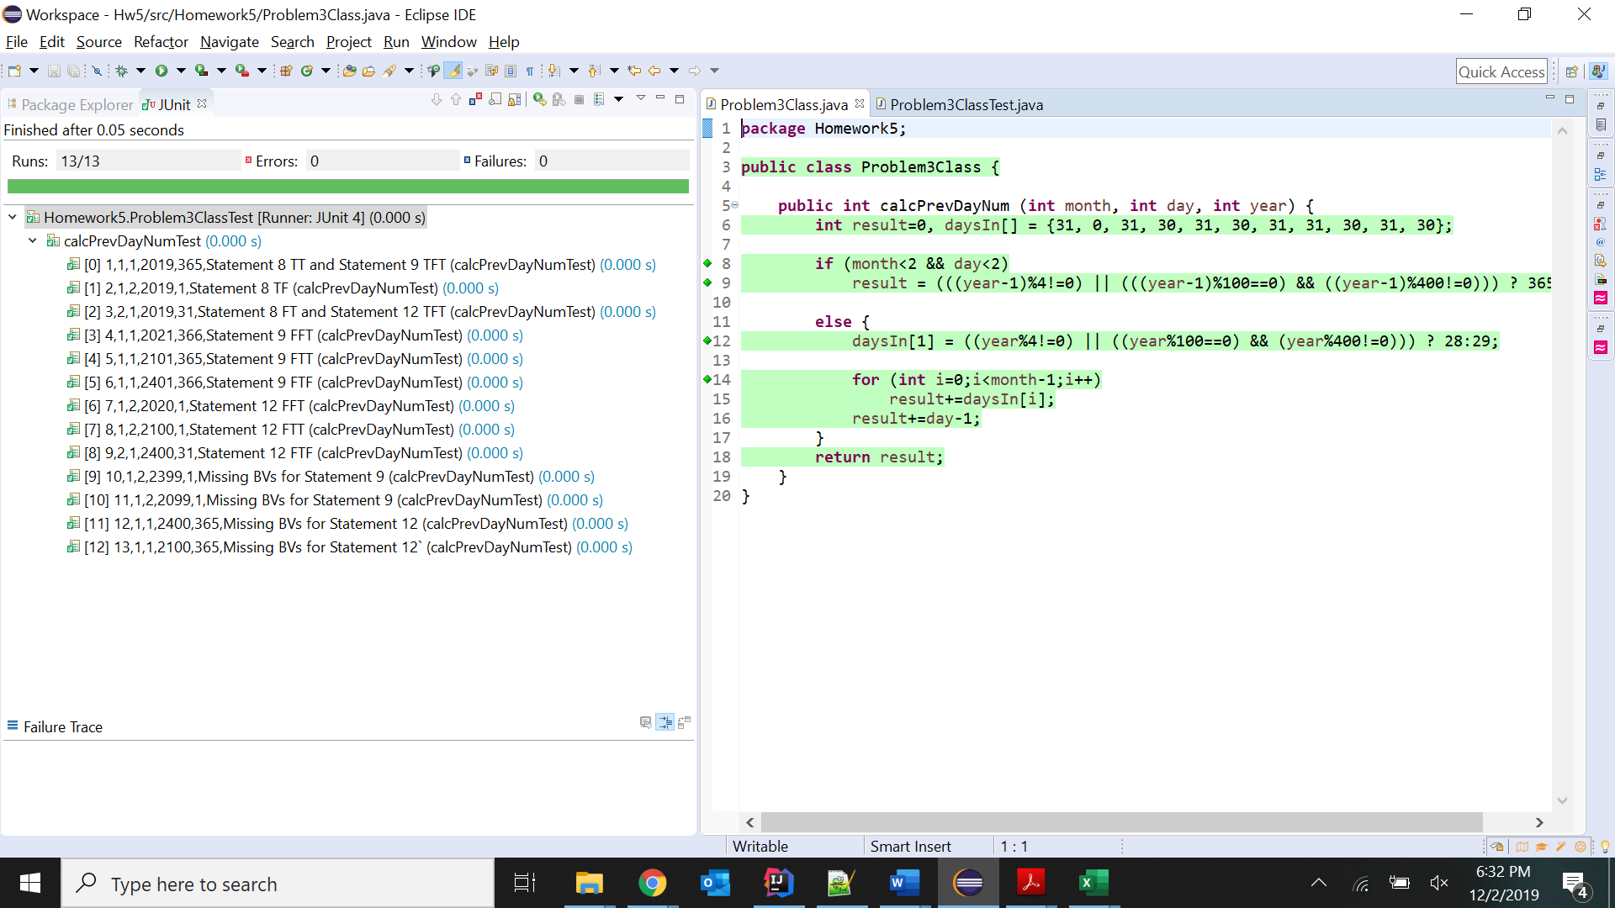

**Problem 4**

**1.Test Case Table:**

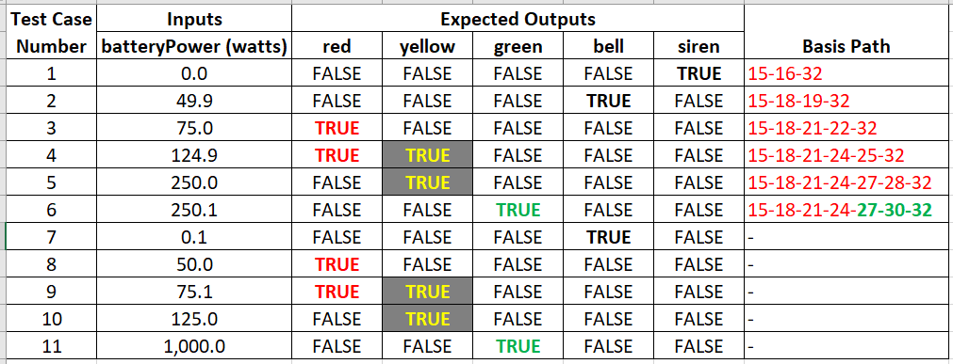

**2. JUnit Pass Indicator:**

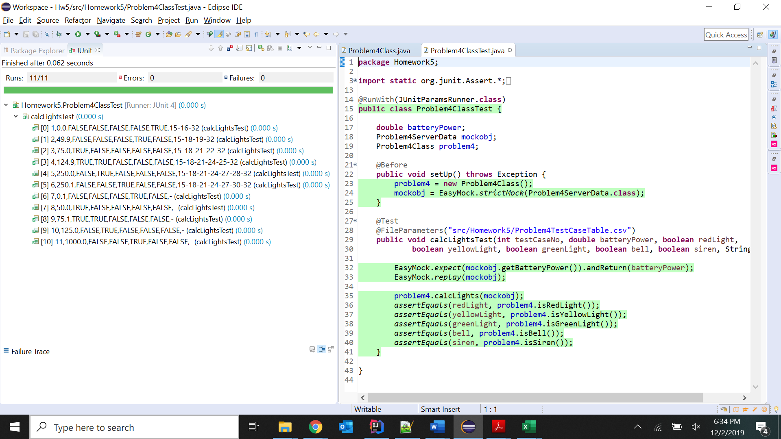

**3. JaCoCo Coverage:**

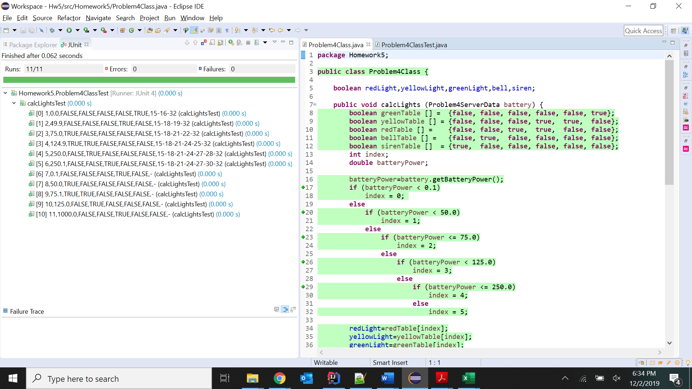

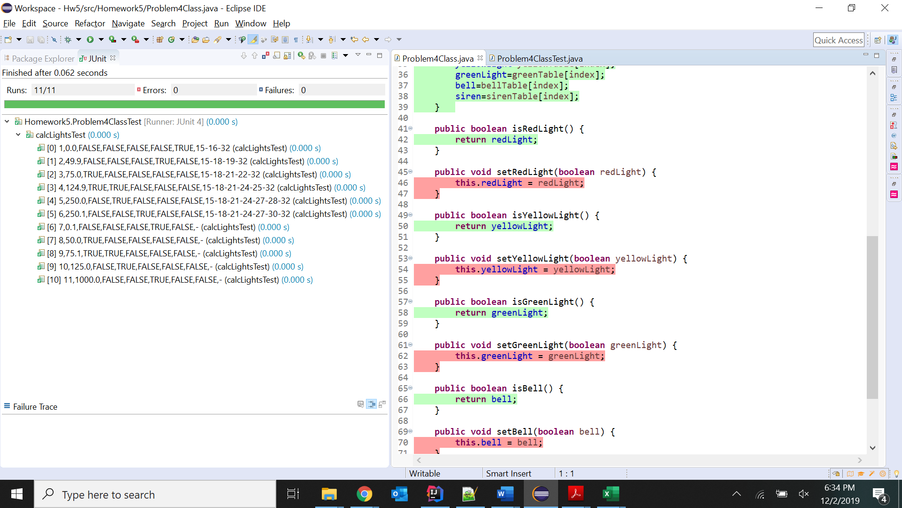

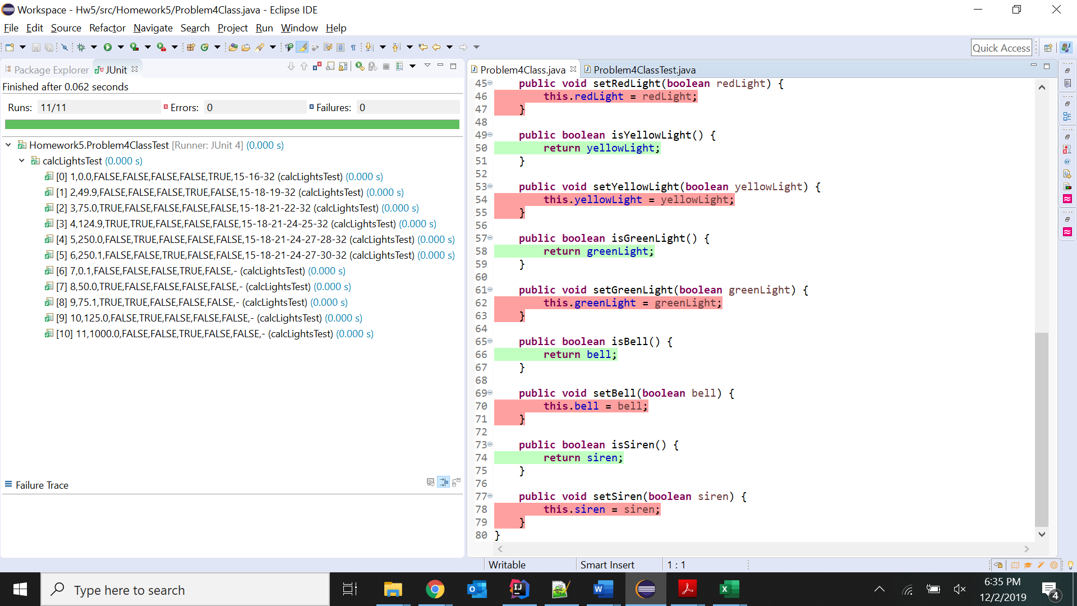

**Problem 5**

**1.Test Case Table:**

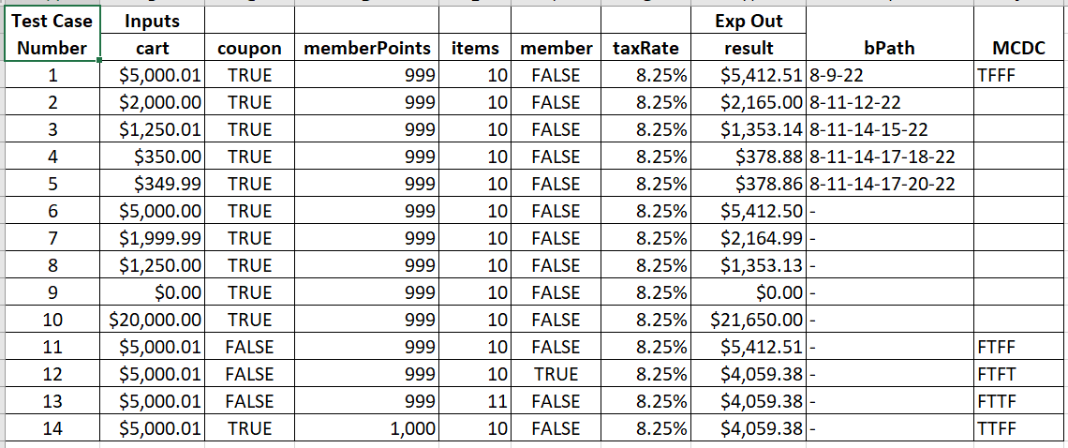

**2. JUnit Test and JaCoCo Coverage:**

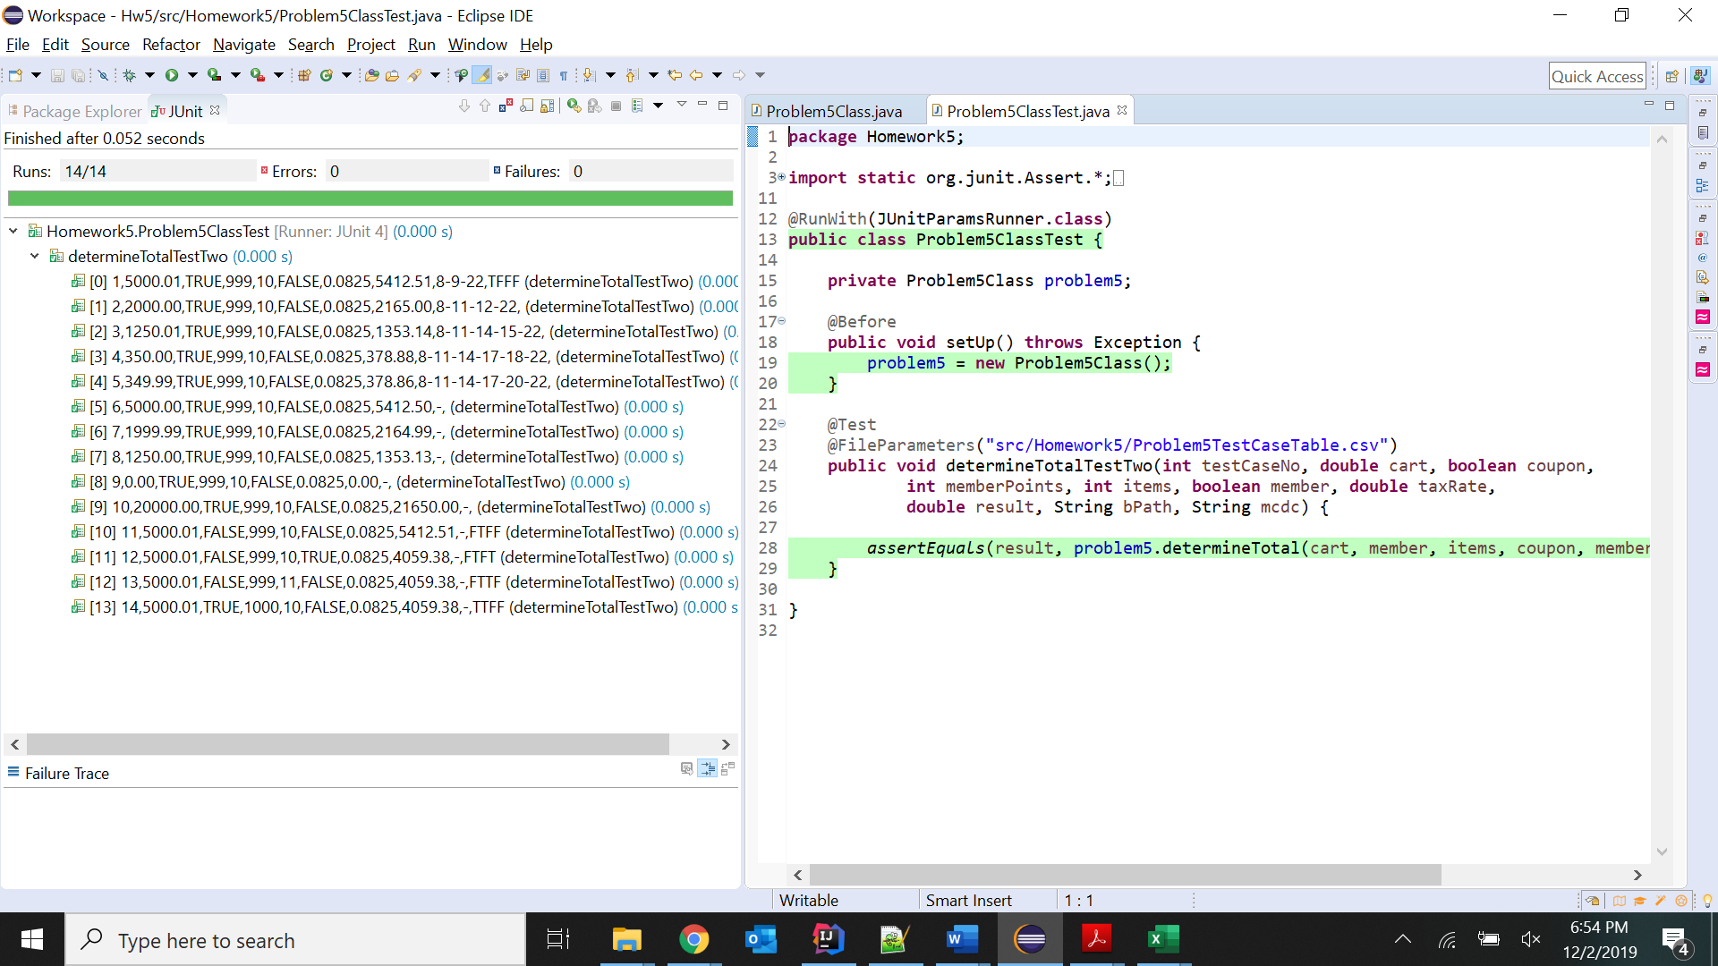

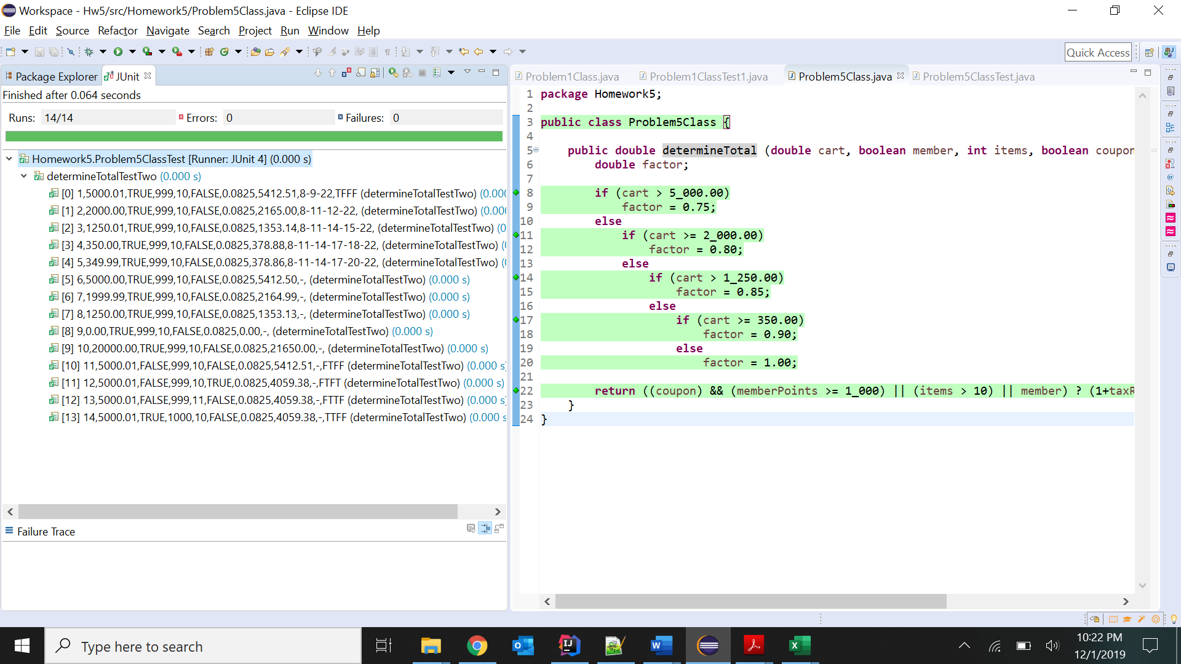

**3.a. PIT Mutation Test:**

I have used have PIT v1.1.9. Kindly check the HTML files for this.

“All Mutators” is set in Pittest. A proof screenshot is given below: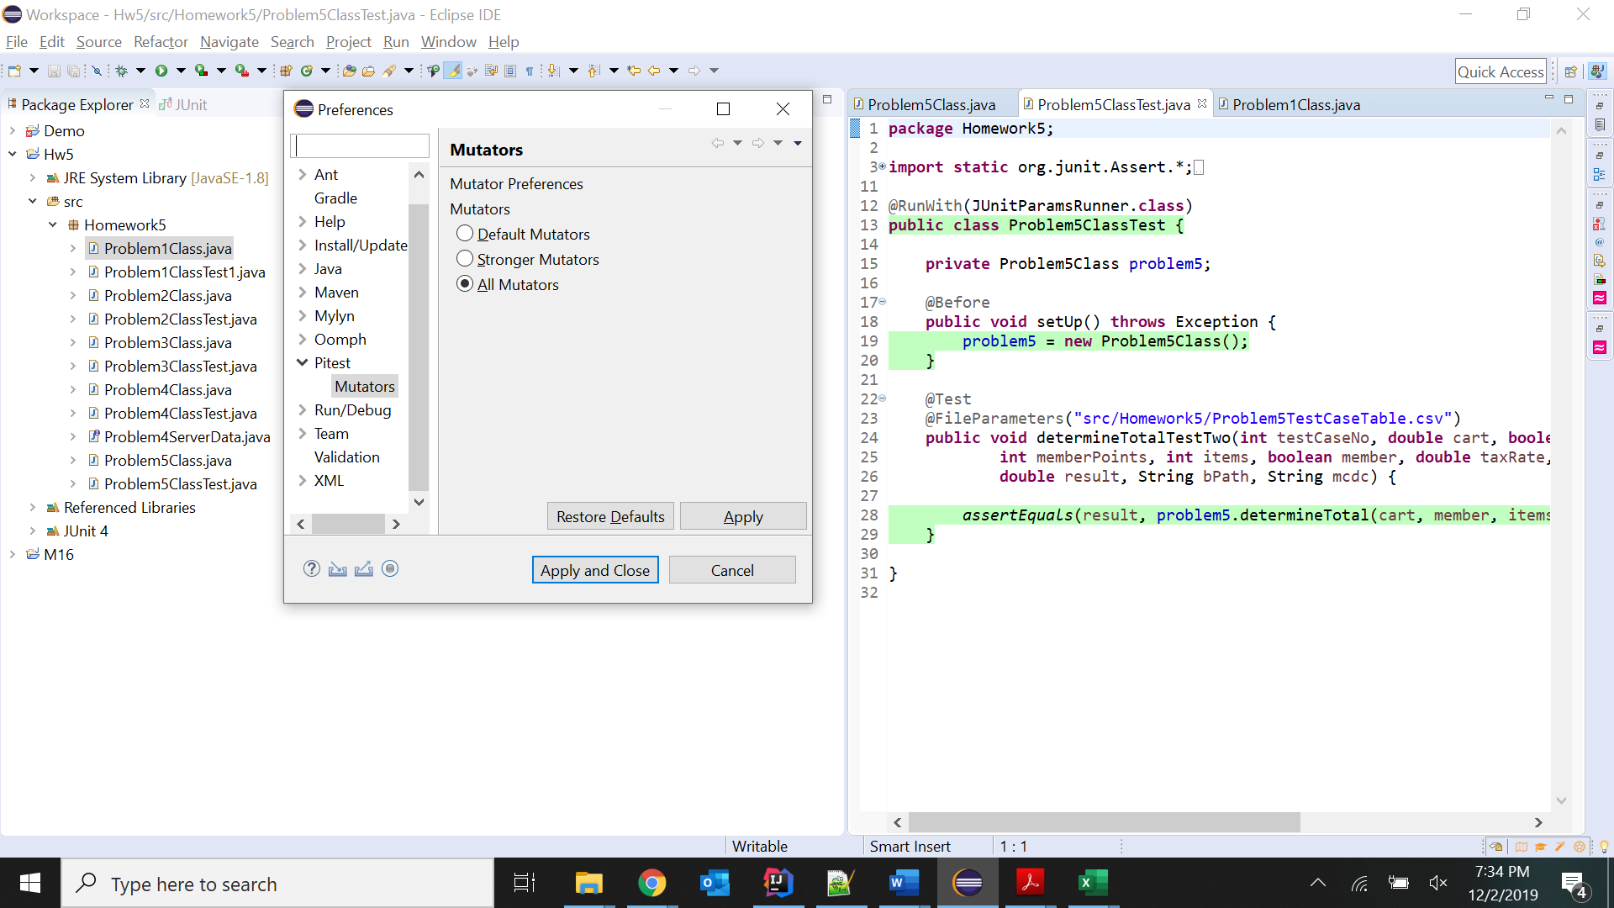

**Problem 1 PIT Mutation test:**

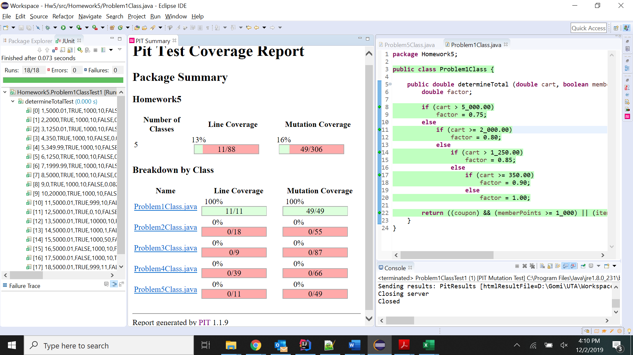

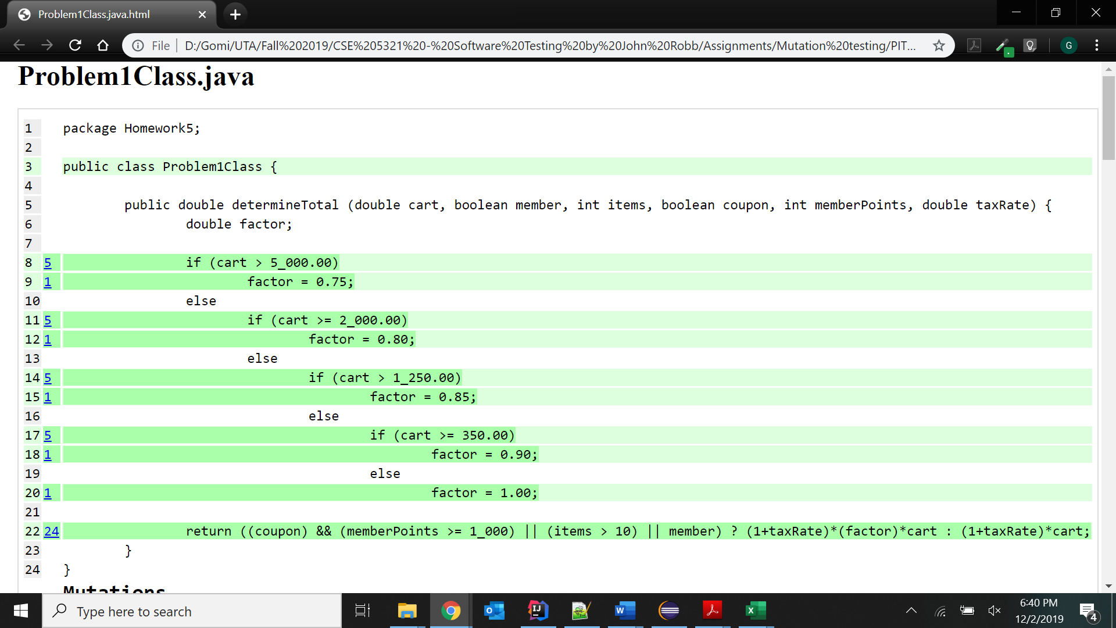

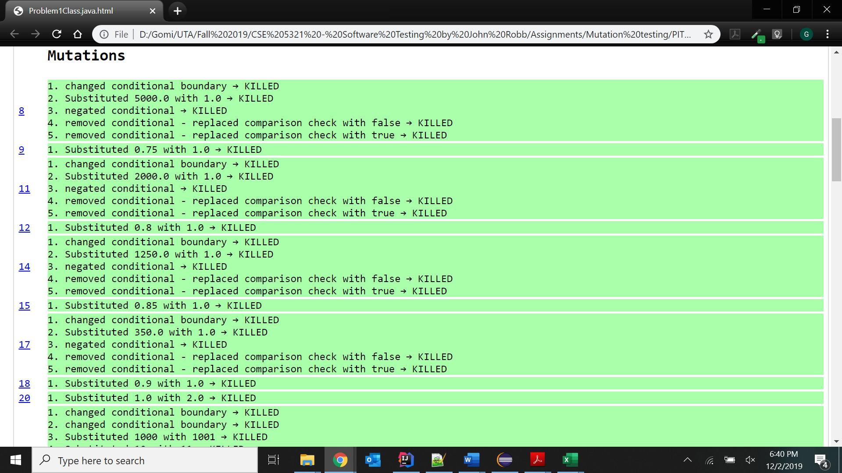

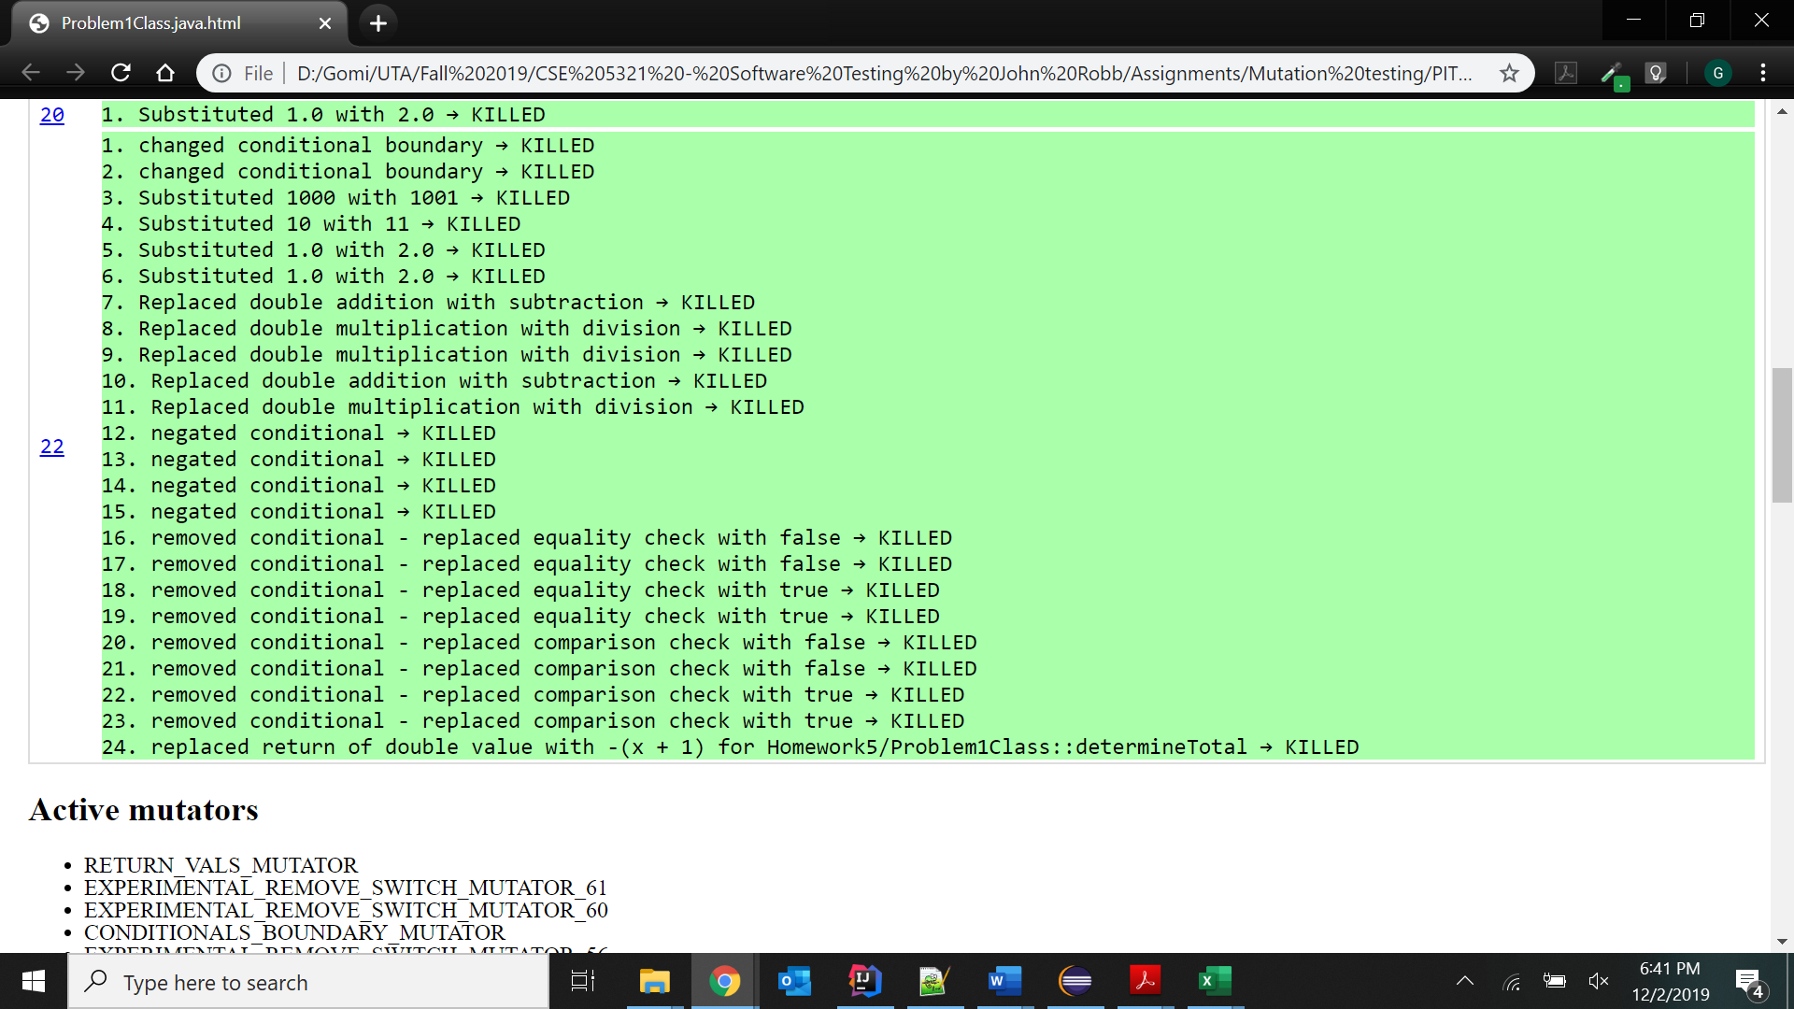

**Problem 5 PIT Mutation test:**

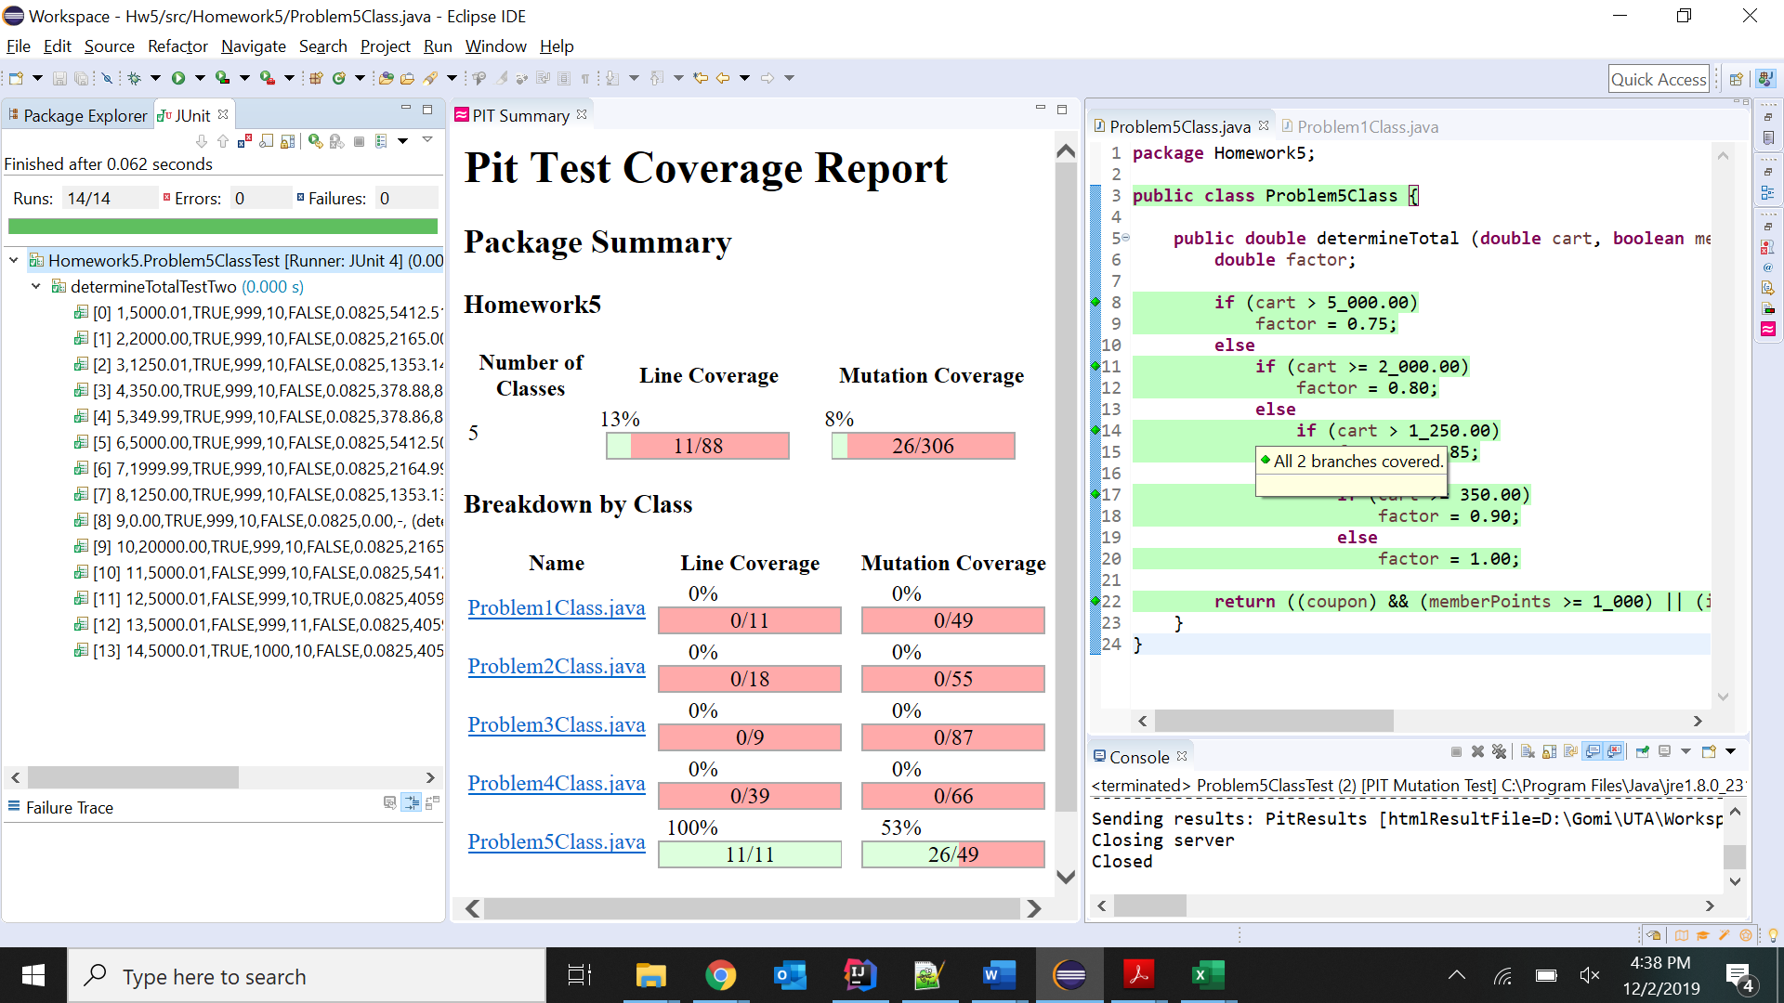

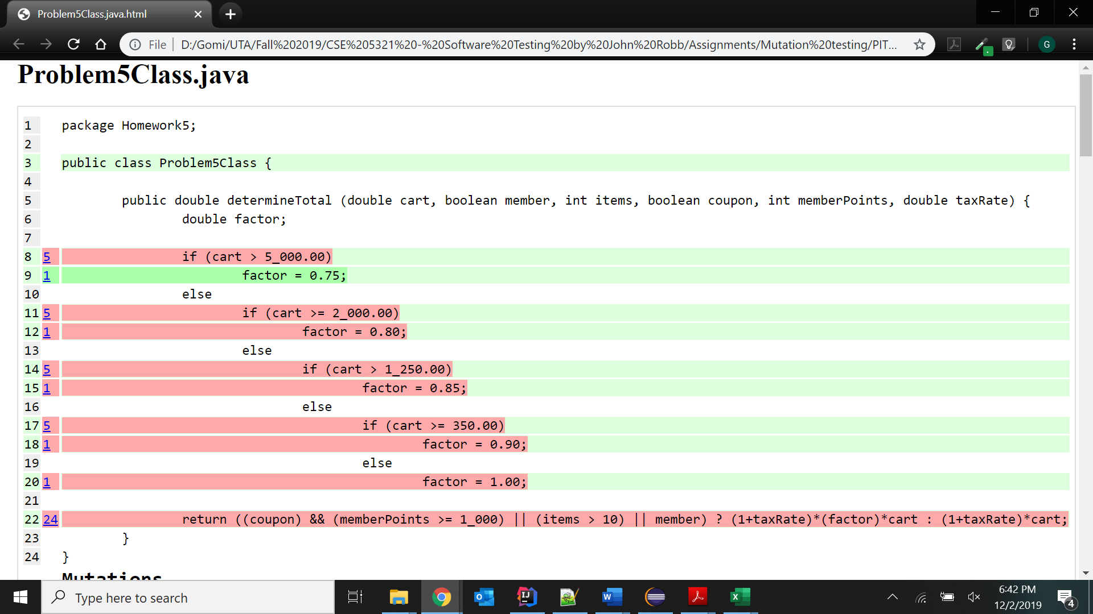

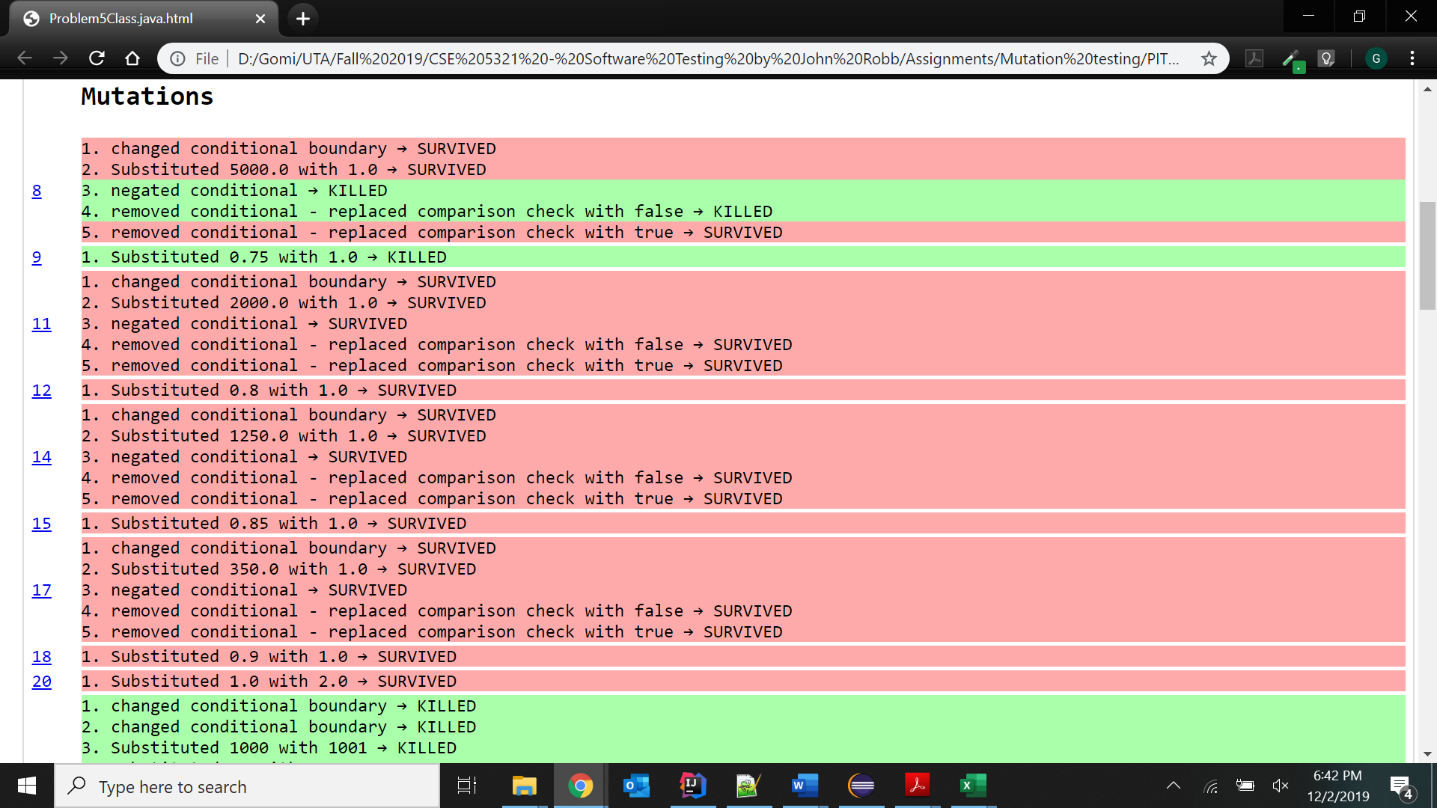

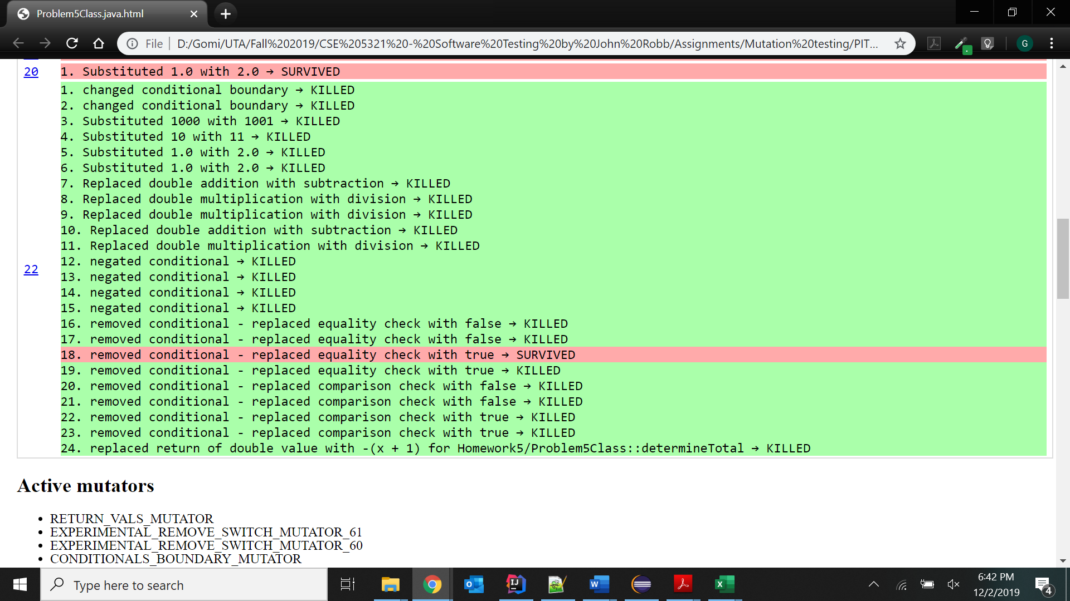

**3.b. Text explanation of PIT coverage analysis of the provided tests:**

The HTML file obtained from PIT Mutation test of Problem 1 shows all green and all the mutants have been killed. The test cases used for Problem 1 have covered all the test cases and has full coverage.

However, the HTML file obtained from PIT Mutation test of Problem 5 shows red color and some mutants have survived (not been killed). One of the reasons for this is that all the boundary conditions were not satisfied in the test cases. Some boundary conditions were omitted.

Though the Basis path conditions were used for the test cases, the extreme range values for memberPoints and items were not considered. They were excluded. Also the MCDC condition FTTF used is different.

The changed conditional boundary, the negated conditional and removed conditional i.e. the comparison checks with false/true condition for cart value survived.

For PIT Mutation test to show green, it requires that we handle all the Basis Path conditions, all the Boundary Value conditions, all the Extreme value conditions for all the variables and all the MCDC tests. If any of the mentioned tests are missing, then some of the mutants survive and it shows red color in the coverage reports.

All the above mentioned conditions are handled in Problem 1 while in Problem 5, some test cases are missing.